**SIMPLEX LINE CODING TRANSCEIVER**

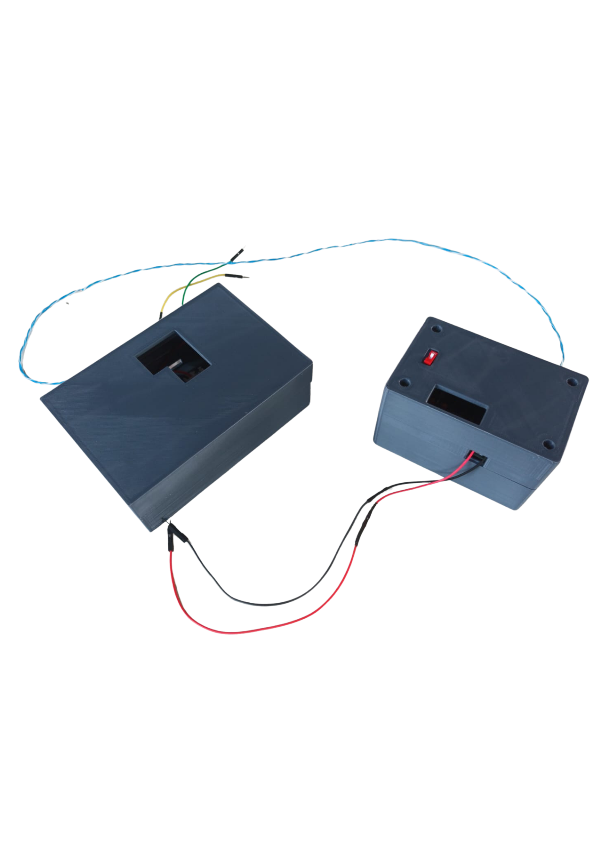

**DATASHEET – GROUP 04**

**Features**

1. **Encoder**

|  |  |
| --- | --- |
| Current Drawn | 0.046 A |
| Operating Voltage | 8 - 24 V |
| Impedance | 92 kΩ |
| PCB Dimension | 9cm x 5cm |
| Enclosure Dimension | 9cm x 5.6cm x 5.6cm |

*Figure 1.1: Encoder PCB Design*

*Figure 1.2: Encoder Enclosure Design*

1. **Decoder**

|  |  |
| --- | --- |
| Current Drawn | 0.017 A |
| Operating Voltage | 8 - 24 V |
| Impedance | 92 kΩ |
| PCB Dimension | 9cm x 5cm |
| Enclosure Dimension | 13cm x 9cm x 4.5cm |

*Figure 1.2: Decoder Enclosure Design*

*Figure 2.1: Decoder PCB Design*

**Signal Specifications**

Encoded Signal : +5 to -5V

Decoded Output Signal : 0 to 5V

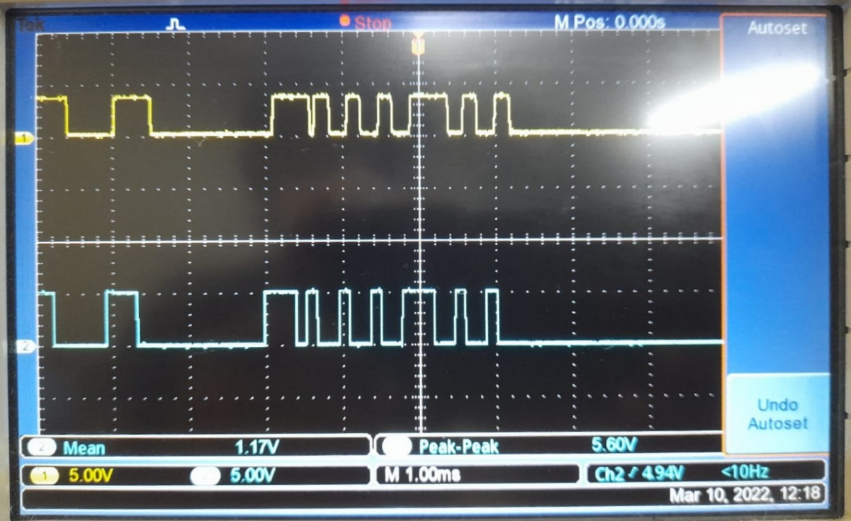

*Figure: Data Signal and Decoded Output Signal*

**Product Specifications**

|  |  |
| --- | --- |
| Encoding Method | Manchester Encoding Scheme |
| Tested Maximum Transfer Distance | 5m |
| Accuracy |  |
| Power Source | 9V Battery |